Project Title: [Font Cambria (Headings) size 14 bold]
(Basic HTML, Hyperlink and Commenting code) [Font Cambria size 12]

- JS Validation: (Client page validation)

Login page:-
Email validation:-

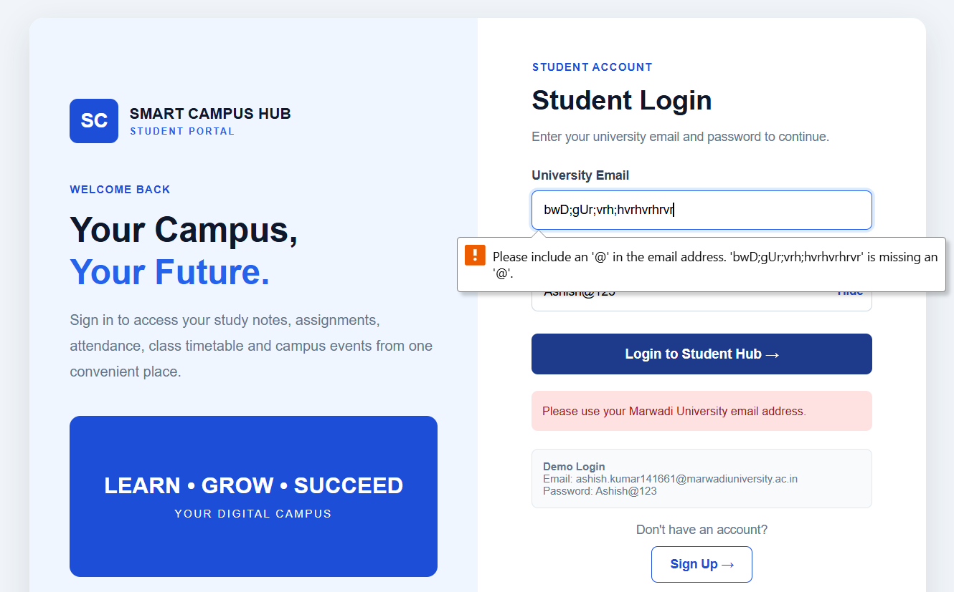
Fig 1.1 JS Validation: All fields are required

Password validation:-
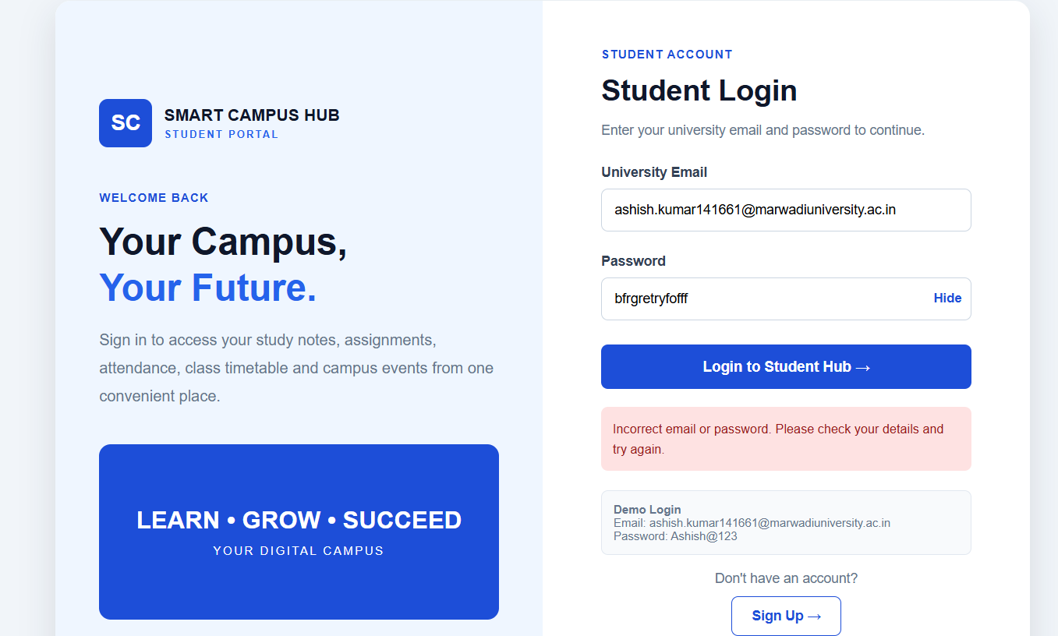
Fig 1.2 JS Validation: Password correct

Singup page:-
Name validation:-
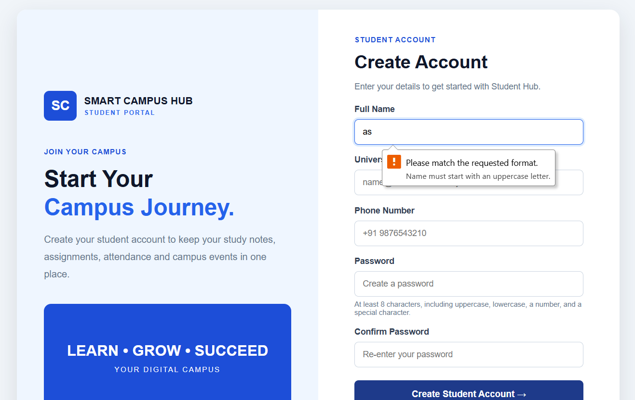
Fig 1.3 JS Validation: Name validation

Email validation:-
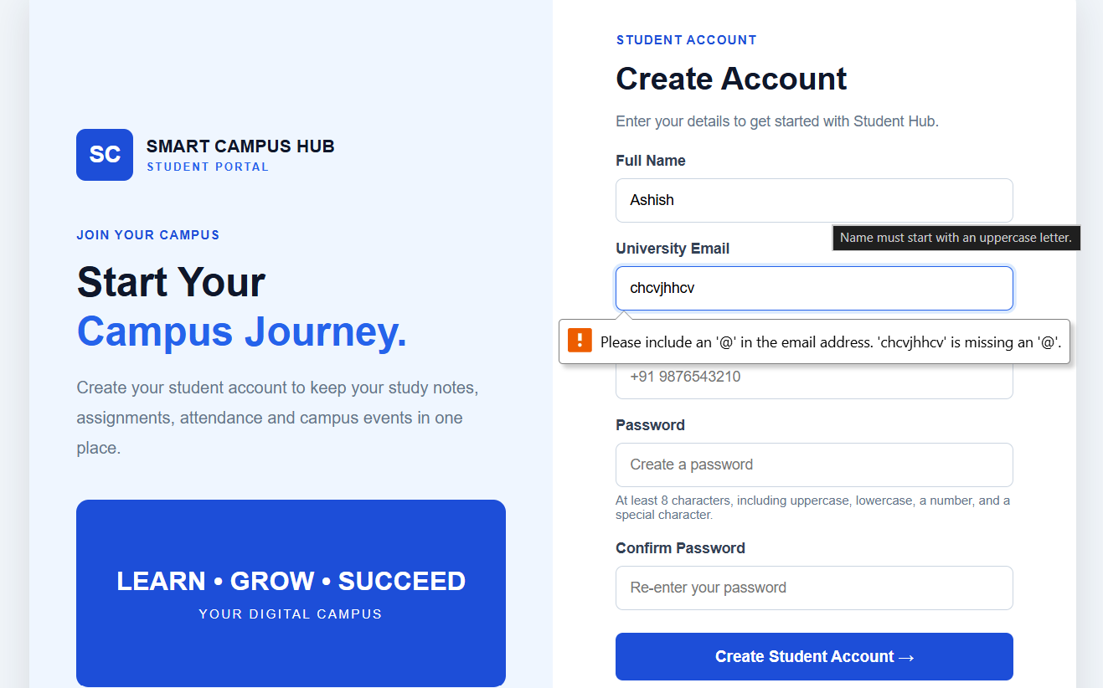
Fig 1.4 JS Validation: Email validation

Phone number validation:-

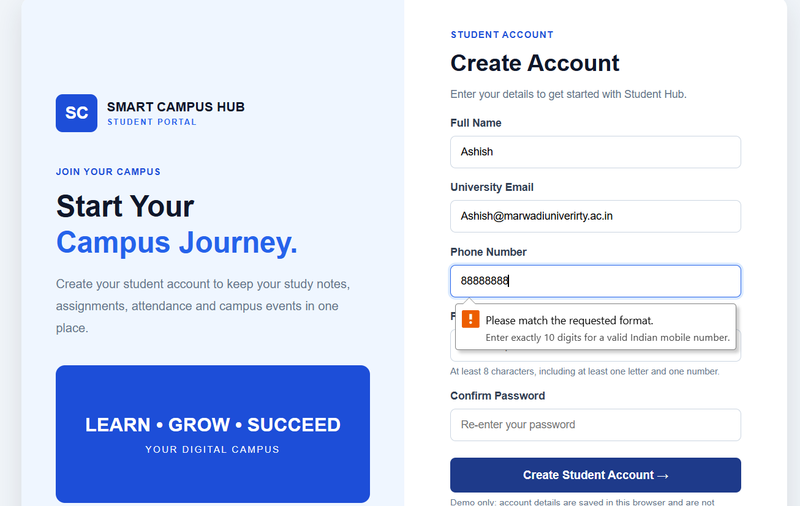

Fig 1.5 JS Validation: Phone number pattern

Password validation:-
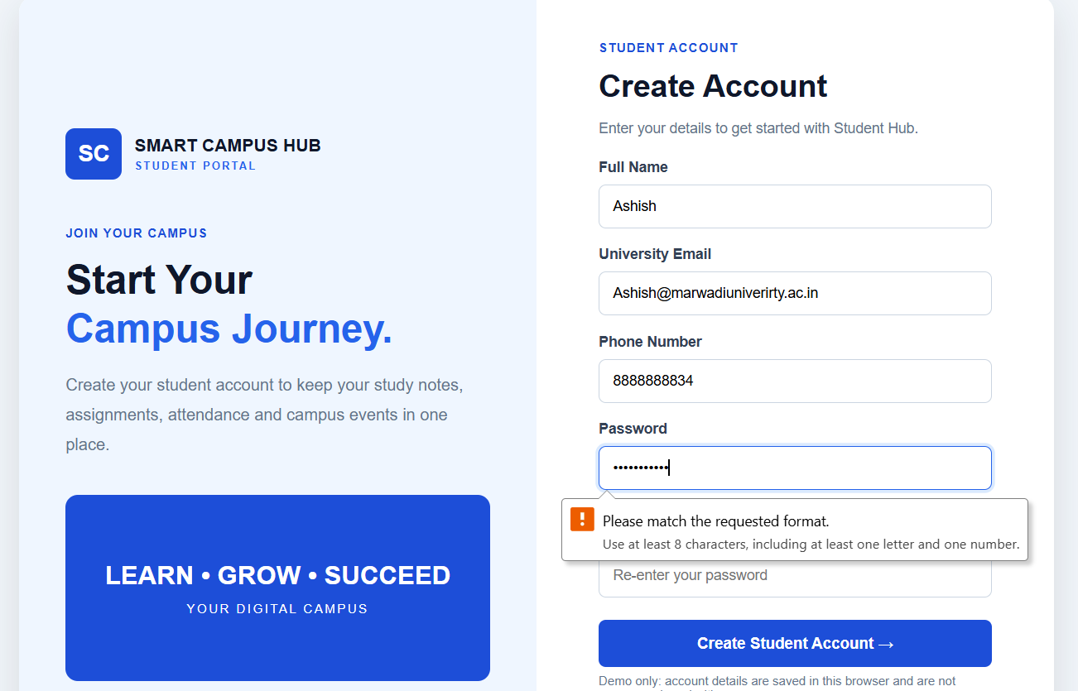
Fig 1.6 JS Validation:Password pattern

Conform password validation:-
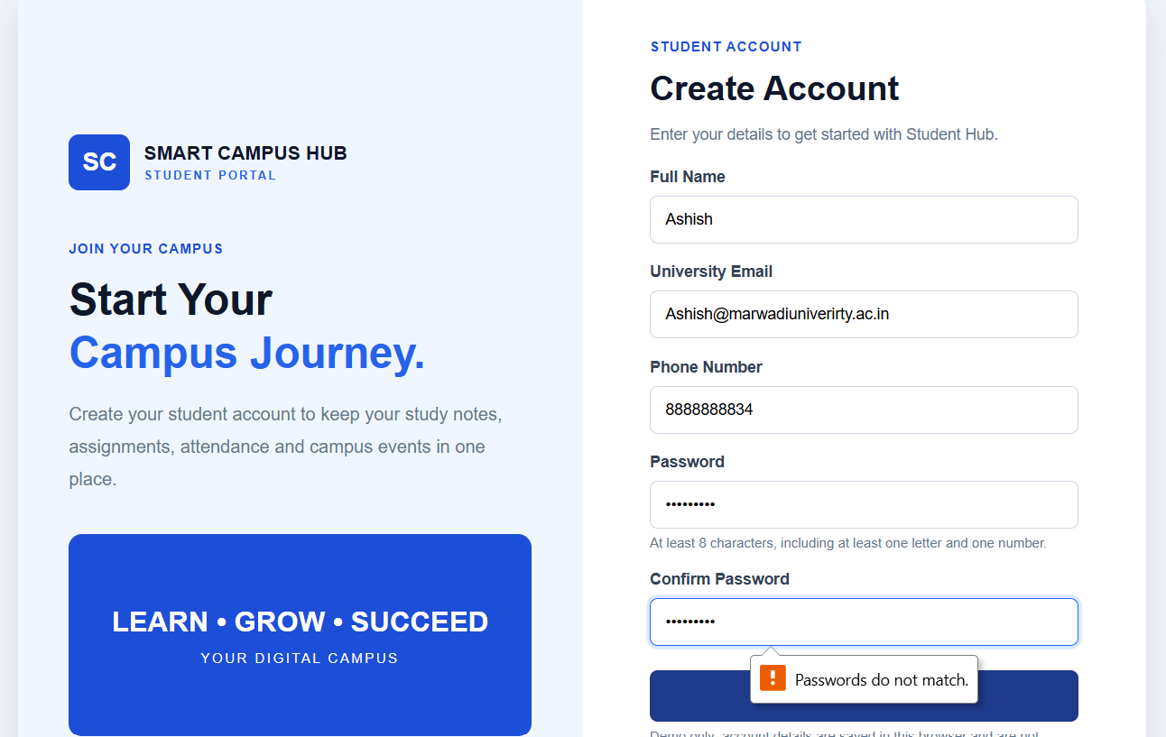
Fig 1.7 JS Validation:Password pattern

Login.html:-
<!DOCTYPE html>
<html lang="en">
<head>
<meta charset="UTF-8">
<meta name="viewport" content="width=device-width, initial-scale=1.0">
<title>Student Login - Smart Campus Hub</title>
<style>
* {
margin: 0;
padding: 0;
box-sizing: border-box;
}
body {
font-family: Arial, sans-serif;
background: #f1f5f9;
color: #1e293b;
min-height: 100vh;
display: flex;
align-items: center;
justify-content: center;
padding: 20px;
}
.login-layout {
display: grid;
grid-template-columns: 1fr 1fr;
max-width: 1000px;
width: 100%;
background: white;
border-radius: 16px;
overflow: hidden;
box-shadow: 0 12px 35px rgba(15, 23, 42, 0.12);
}
/* Left Side */
.login-intro {
padding: 45px;
background: #eff6ff;
display: flex;
flex-direction: column;
justify-content: center;
}
.brand {
display: flex;
align-items: center;
gap: 12px;
margin-bottom: 45px;
}
.brand-mark {
background: #1d4ed8;
color: white;
padding: 12px;
border-radius: 9px;
font-size: 22px;
font-weight: bold;
}
.brand-copy {
color: #0f172a;
font-size: 17px;
font-weight: bold;
}
.brand-copy small {
display: block;
font-size: 10px;
color: #2563eb;
letter-spacing: 2px;
margin-top: 4px;
}
.wire-label {
color: #1d4ed8;
font-size: 12px;
font-weight: bold;
letter-spacing: 1px;
text-transform: uppercase;
}
.login-intro h1 {
font-size: 38px;
line-height: 1.25;
color: #0f172a;
margin: 15px 0;
}
.login-intro h1 span {
color: #2563eb;
}
.login-intro p {
color: #64748b;
line-height: 1.8;
}
.login-art {
margin-top: 35px;
min-height: 180px;
border-radius: 12px;
background: #1d4ed8;
display: flex;
justify-content: center;
align-items: center;
text-align: center;
color: white;
padding: 20px;
}
.login-art div {
font-size: 25px;
font-weight: bold;
}
.login-art span {
display: block;
font-size: 12px;
font-weight: normal;
letter-spacing: 2px;
margin-top: 10px;
}
/* Right Side */
.login-form {
display: flex;
justify-content: center;
align-items: center;
padding: 45px;
}
.form-panel {
width: 100%;
max-width: 380px;
}
.form-panel h2 {
color: #0f172a;
font-size: 30px;
margin: 12px 0;
}
.muted {
color: #64748b;
font-size: 14px;
line-height: 1.7;
}
.field {
margin-top: 22px;
}
.field label {
display: block;
margin-bottom: 8px;
font-size: 14px;
font-weight: bold;
color: #334155;
}
.input {
width: 100%;
padding: 13px;
border: 1px solid #cbd5e1;
border-radius: 7px;
outline: none;
font-size: 14px;
background: #ffffff;
}
.input:focus {
border-color: #2563eb;
box-shadow: 0 0 0 3px #dbeafe;
}
.password-box {
position: relative;
}
.password-box .input {
padding-right: 65px;
}
.toggle-password {
position: absolute;
right: 10px;
top: 50%;
transform: translateY(-50%);
border: none;
background: transparent;
color: #1d4ed8;
cursor: pointer;
font-weight: bold;
}
.button {
width: 100%;
display: block;
margin-top: 25px;
padding: 14px;
border: none;
border-radius: 7px;
background: #1d4ed8;
color: white;
font-size: 15px;
font-weight: bold;
cursor: pointer;
transition: 0.3s;
}
.button:hover {
background: #1e3a8a;
}
.message {
display: none;
margin-top: 18px;
padding: 12px;
border-radius: 7px;
background: #fee2e2;
color: #991b1b;
font-size: 13px;
line-height: 1.6;
}
.message.success {
background: #dcfce7;
color: #166534;
}
.back-link {
display: block;
text-align: center;
margin-top: 22px;
color: #1d4ed8;
font-size: 14px;
font-weight: bold;
}
.back-link:hover {
text-decoration: underline;
}
.signup-link {
display: block;
text-align: center;
margin-top: 16px;
color: #64748b;
font-size: 14px;
}
.signup-link a {
display: inline-block;
margin-top: 10px;
padding: 11px 20px;
border: 1px solid #1d4ed8;
border-radius: 7px;
background: #ffffff;
color: #1d4ed8;
font-weight: bold;
text-decoration: none;
transition: 0.3s;
}
.signup-link a:hover {
background: #eff6ff;
}
.demo-note {
margin-top: 20px;
padding: 12px;
background: #f8fafc;
border: 1px solid #e2e8f0;
border-radius: 7px;
font-size: 12px;
color: #64748b;
}
/* Mobile */
@media (max-width: 700px) {
.login-layout {
grid-template-columns: 1fr;
}
.login-intro {
padding: 28px;
}
.brand {
margin-bottom: 25px;
}
.login-intro h1 {
font-size: 30px;
}
.login-art {
min-height: 120px;
margin-top: 22px;
}
.login-form {
padding: 30px 25px;
}
}
</style>
</head>
<body>
<div class="login-layout">
<!-- Welcome Section -->
<section class="login-intro">
<div class="brand">
<span class="brand-mark">SC</span>
<span class="brand-copy">
SMART CAMPUS HUB
<small>STUDENT PORTAL</small>
</span>
</div>
<span class="wire-label">WELCOME BACK</span>
<h1>Your Campus,<br>
<span>Your Future.</span>
</h1>
<p>
Sign in to access your study notes, assignments,
attendance, class timetable and campus events
from one convenient place.
</p>
<div class="login-art">
<div>
LEARN • GROW • SUCCEED
<span>YOUR DIGITAL CAMPUS</span>
</div>
</div>
</section>
<!-- Login Form -->
<section class="login-form">
<div class="form-panel">
<span class="wire-label">STUDENT ACCOUNT</span>
<h2>Student Login</h2>
<p class="muted">
Enter your university email and password to continue.
</p>
<form id="loginForm">
<!-- Email Field -->
<div class="field">
<label for="email">University Email</label>
<input
class="input"
type="email"
id="email"
value="ashish.kumar141661@marwadiuniversity.ac.in"
placeholder="Enter your university email"
autocomplete="username"
required>
</div>
<!-- Password Field -->
<div class="field">
<label for="password">Password</label>
<div class="password-box">
<input
class="input"
type="password"
id="password"
placeholder="Enter your password"
autocomplete="current-password"
minlength="8"
pattern="(?=.*[0-9]).{8,}"
title="Password must be at least 8 characters and contain at least one number."
required>
<button
class="toggle-password"
type="button"
id="togglePassword">
Show
</button>
</div>
</div>
<!-- Login Button -->
<button class="button" type="submit">
Login to Student Hub →
</button>
<!-- Validation Message -->
<div class="message" id="message" role="status"></div>
</form>
<!-- Demo Credentials -->
<div class="demo-note">
<strong>Demo Login</strong><br>
Email:
ashish.kumar141661@marwadiuniversity.ac.in<br>
Password: Ashish@123
</div>
<!-- Sign Up Link -->
<p class="signup-link">
Don't have an account?<br>
<a href="student-signup.html">
Sign Up →
</a>
</p>
<!-- Back Link -->
<a href="home.html" class="back-link">
← Back to Home
</a>
</div>
</section>
</div>
<script>
// Get HTML Elements
const form = document.getElementById("loginForm");
const email = document.getElementById("email");
const password = document.getElementById("password");
const message = document.getElementById("message");
const toggle = document.getElementById("togglePassword");
// Fill Email From Sign Up Page
const signupEmail =
new URLSearchParams(window.location.search).get("email");
if (signupEmail) {
email.value = signupEmail;
}
// Show / Hide Password
toggle.addEventListener("click", function () {
if (password.type === "password") {
password.type = "text";
toggle.textContent = "Hide";
} else {
password.type = "password";
toggle.textContent = "Show";
}
});
// Login Form Validation
form.addEventListener("submit", function (event) {
event.preventDefault();
// Get Input Values
const enteredEmail = email.value.trim().toLowerCase();
const enteredPassword = password.value;
// Hide Previous Message
message.style.display = "none";
// Validation 1: Email Format
const emailPattern = /^[^\s@]+@[^\s@]+\.[^\s@]+$/;
if (!emailPattern.test(enteredEmail)) {
message.className = "message";
message.textContent =
"Please enter a valid email address.";
message.style.display = "block";
return;
}
// Validation 2: University Email Domain
if (!enteredEmail.endsWith("@marwadiuniversity.ac.in")) {
message.className = "message";
message.textContent =
"Please use your Marwadi University email address.";
message.style.display = "block";
return;
}
// Validation 3: Password Length (Minimum 8 Characters)
if (enteredPassword.length < 8) {
message.className = "message";
message.textContent =
"Password must contain at least 8 characters.";
message.style.display = "block";
return;
}
// Demo Account Check
const demoAccount =
enteredEmail ===
"ashish.kumar141661@marwadiuniversity.ac.in" &&
enteredPassword === "Ashish@123";
// Signup Account Check
try {
const accounts = JSON.parse(
localStorage.getItem("smartCampusStudentAccounts") || "[]"
);
const signupAccount =
Array.isArray(accounts) &&
accounts.some(function (account) {
return (
account.email === enteredEmail &&
account.password === enteredPassword
);
});
// Successful Login
if (demoAccount || signupAccount) {
message.className = "message success";
message.textContent =
"Login successful! Opening Student Hub...";
message.style.display = "block";
// Redirect To Student Dashboard
setTimeout(function () {
window.location.href = "student-dashboard.html";
}, 700);
return;
}
// Incorrect Credentials
message.className = "message";
message.textContent =
"Incorrect email or password. Please check your details and try again.";
message.style.display = "block";
} catch (error) {
// Local Storage Error
message.className = "message";
message.textContent =
"Unable to check saved accounts in this browser. Please open the pages through a local web server and try again.";
message.style.display = "block";
}
});
</script>
</body>
</html>
Singup.html:-
<!DOCTYPE html>
<html lang="en">
<head>
<meta charset="UTF-8">
<meta name="viewport" content="width=device-width, initial-scale=1.0">
<title>Student Sign Up - Smart Campus Hub</title>
<style>
* {
margin: 0;
padding: 0;
box-sizing: border-box;
}
body {
font-family: Arial, sans-serif;
background: #f1f5f9;
color: #1e293b;
min-height: 100vh;
display: flex;
align-items: center;
justify-content: center;
padding: 20px;
}
.signup-layout {
display: grid;
grid-template-columns: 1fr 1fr;
max-width: 1000px;
width: 100%;
background: white;
border-radius: 16px;
overflow: hidden;
box-shadow: 0 12px 35px rgba(15, 23, 42, 0.12);
}
.signup-intro {
padding: 45px;
background: #eff6ff;
display: flex;
flex-direction: column;
justify-content: center;
}
.brand {
display: flex;
align-items: center;
gap: 12px;
margin-bottom: 45px;
}
.brand-mark {
background: #1d4ed8;
color: white;
padding: 12px;
border-radius: 9px;
font-size: 22px;
font-weight: bold;
}
.brand-copy {
color: #0f172a;
font-size: 17px;
font-weight: bold;
}
.brand-copy small {
display: block;
font-size: 10px;
color: #2563eb;
letter-spacing: 2px;
margin-top: 4px;
}
.wire-label {
color: #1d4ed8;
font-size: 12px;
font-weight: bold;
letter-spacing: 1px;
text-transform: uppercase;
}
.signup-intro h1 {
font-size: 38px;
line-height: 1.25;
color: #0f172a;
margin: 15px 0;
}
.signup-intro h1 span {
color: #2563eb;
}
.signup-intro p {
color: #64748b;
line-height: 1.8;
}
.signup-art {
margin-top: 35px;
min-height: 180px;
border-radius: 12px;
background: #1d4ed8;
display: flex;
justify-content: center;
align-items: center;
text-align: center;
color: white;
padding: 20px;
}
.signup-art div {
font-size: 25px;
font-weight: bold;
}
.signup-art span {
display: block;
font-size: 12px;
font-weight: normal;
letter-spacing: 2px;
margin-top: 10px;
}
.signup-form {
display: flex;
justify-content: center;
align-items: center;
padding: 40px 45px;
}
.form-panel {
width: 100%;
max-width: 380px;
}
.form-panel h2 {
color: #0f172a;
font-size: 30px;
margin: 12px 0;
}
.muted {
color: #64748b;
font-size: 14px;
line-height: 1.7;
}
.field {
margin-top: 17px;
}
.field label {
display: block;
margin-bottom: 8px;
font-size: 14px;
font-weight: bold;
color: #334155;
}
.input {
width: 100%;
padding: 12px 13px;
border: 1px solid #cbd5e1;
border-radius: 7px;
outline: none;
font-size: 14px;
background: #ffffff;
}
.input:focus {
border-color: #2563eb;
box-shadow: 0 0 0 3px #dbeafe;
}
.hint {
margin-top: 6px;
color: #64748b;
font-size: 12px;
}
.button {
width: 100%;
display: block;
margin-top: 22px;
padding: 14px;
border: none;
border-radius: 7px;
background: #1d4ed8;
color: white;
font-size: 15px;
font-weight: bold;
cursor: pointer;
transition: 0.3s;
}
.button:hover {
background: #1e3a8a;
}
.message {
display: none;
margin-top: 16px;
padding: 12px;
border-radius: 7px;
background: #dcfce7;
color: #166534;
font-size: 13px;
line-height: 1.6;
}
.message.error {
background: #fee2e2;
color: #991b1b;
}
.account-link {
display: block;
text-align: center;
margin-top: 18px;
color: #64748b;
font-size: 14px;
}
.account-link a,
.back-link {
color: #1d4ed8;
font-weight: bold;
text-decoration: none;
}
.back-link {
display: block;
text-align: center;
margin-top: 17px;
font-size: 14px;
}
.account-link a:hover,
.back-link:hover {
text-decoration: underline;
}
@media (max-width: 700px) {
.signup-layout {
grid-template-columns: 1fr;
}
.signup-intro {
padding: 28px;
}
.brand {
margin-bottom: 25px;
}
.signup-intro h1 {
font-size: 30px;
}
.signup-art {
min-height: 110px;
margin-top: 22px;
}
.signup-form {
padding: 30px 25px;
}
}
</style>
</head>
<body>
<div class="signup-layout">
<section class="signup-intro">
<div class="brand">
<span class="brand-mark">SC</span>
<span class="brand-copy">
SMART CAMPUS HUB
<small>STUDENT PORTAL</small>
</span>
</div>
<span class="wire-label">JOIN YOUR CAMPUS</span>
<h1>Start Your<br><span>Campus Journey.</span></h1>
<p>
Create your student account to keep your study notes,
assignments, attendance and campus events in one place.
</p>
<div class="signup-art">
<div>
LEARN • GROW • SUCCEED
<span>YOUR DIGITAL CAMPUS</span>
</div>
</div>
</section>
<section class="signup-form">
<div class="form-panel">
<span class="wire-label">STUDENT ACCOUNT</span>
<h2>Create Account</h2>
<p class="muted">Enter your details to get started with Student Hub.</p>
<form id="signupForm">
<div class="field">
<label for="fullName">Full Name</label>
<input class="input" type="text" id="fullName" name="fullName"
placeholder="Enter your full name" autocomplete="name"
minlength="2" maxlength="80" pattern="[A-Z].*"
title="Name must start with an uppercase letter." required>
</div>
<div class="field">
<label for="email">University Email</label>
<input class="input" type="email" id="email" name="email"
placeholder="name@marwadiuniversity.ac.in" autocomplete="email"
pattern="[A-Za-z0-9._%+-]+@marwadiuniversity\.ac\.in"
title="Enter a valid Marwadi University email address." required>
</div>
<div class="field">
<label for="phone">Phone Number</label>
<input class="input" type="tel" id="phone" name="phone"
placeholder="9876543210" autocomplete="tel"
pattern="[6-9][0-9]{9}"
title="Enter exactly 10 digits for a valid Indian mobile number."
maxlength="10" required>
</div>
<div class="field">
<label for="password">Password</label>
<input class="input" type="password" id="password" name="password"
placeholder="Create a password" autocomplete="new-password"
minlength="8"
pattern="(?=.*[A-Za-z])(?=.*[0-9]).{8,}"
title="Use at least 8 characters, including at least one letter and one number."
required>
<p class="hint">At least 8 characters, including at least one letter and one number.</p>
</div>
<div class="field">
<label for="confirmPassword">Confirm Password</label>
<input class="input" type="password" id="confirmPassword" name="confirmPassword"
placeholder="Re-enter your password" autocomplete="new-password" required>
</div>
<button class="button" type="submit">Create Student Account →</button>
<div class="message" id="message" role="status" aria-live="polite"></div>
</form>
<p class="hint">Demo only: account details are saved in this browser and are not secure or shared with a server.</p>
<p class="account-link">
Already have an account? <a href="student-login.html">Student Login</a>
</p>
<a href="home.html" class="back-link">← Back to Home</a>
</div>
</section>
</div>
<script>
const form = document.getElementById("signupForm");
const password = document.getElementById("password");
const confirmPassword = document.getElementById("confirmPassword");
const message = document.getElementById("message");
const email = document.getElementById("email");
confirmPassword.addEventListener("input", function () {
confirmPassword.setCustomValidity(
confirmPassword.value === password.value
? ""
: "Passwords do not match."
);
});
password.addEventListener("input", function () {
if (confirmPassword.value !== "") {
confirmPassword.setCustomValidity(
confirmPassword.value === password.value
? ""
: "Passwords do not match."
);
}
});
form.addEventListener("submit", function (event) {
event.preventDefault();
const accountEmail = email.value.trim().toLowerCase();
try {
const accounts = JSON.parse(
localStorage.getItem("smartCampusStudentAccounts") || "[]"
);
if (!Array.isArray(accounts)) {
throw new Error("Saved account data is invalid.");
}
if (accounts.some(function (account) {
return account.email === accountEmail;
})) {
message.className = "message error";
message.textContent = "An account with this email already exists. Please log in instead.";
message.style.display = "block";
return;
}
accounts.push({
name: document.getElementById("fullName").value.trim(),
email: accountEmail,
phone: document.getElementById("phone").value.trim(),
password: password.value
});
localStorage.setItem("smartCampusStudentAccounts", JSON.stringify(accounts));
message.className = "message";
message.textContent = "Account created! Opening the login page...";
message.style.display = "block";
setTimeout(function () {
window.location.href =
"student-login.html?email=" + encodeURIComponent(accountEmail);
}, 900);
} catch (error) {
message.className = "message error";
message.textContent =
"Could not save your account in this browser. Open these pages through a local web server and try again.";
message.style.display = "block";
}
});
</script>
</body>
</html>

- Admin page validation:-
Username validation:-
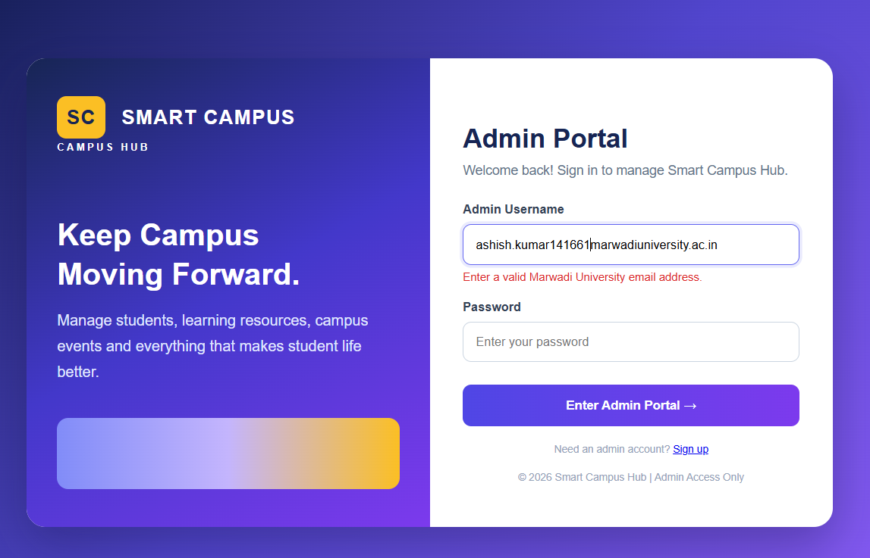
Fig 1.1 JS Validation:username validation pattern

Password validation:-
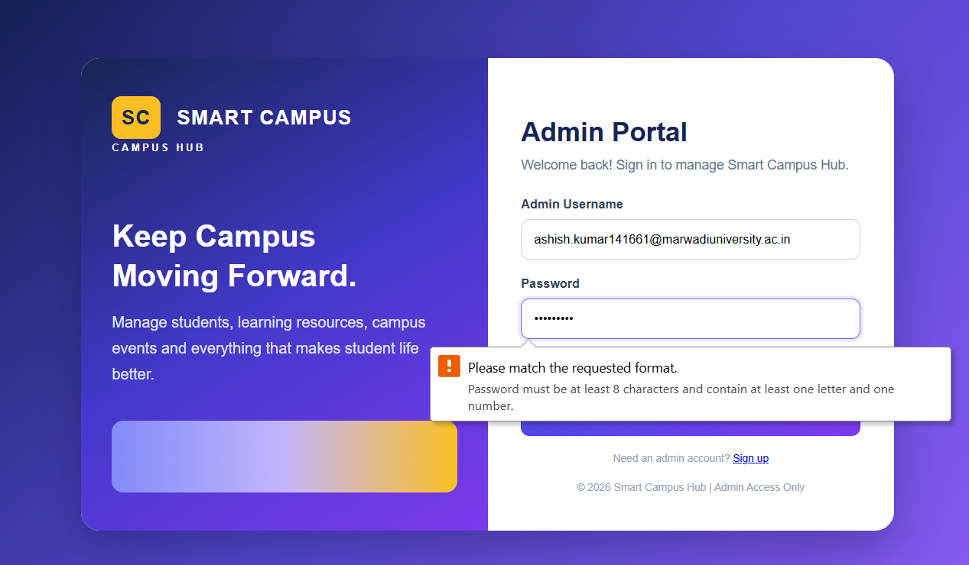
Fig 1.2 JS Validation:username validation pattern

Singup page:-
Name validation:-
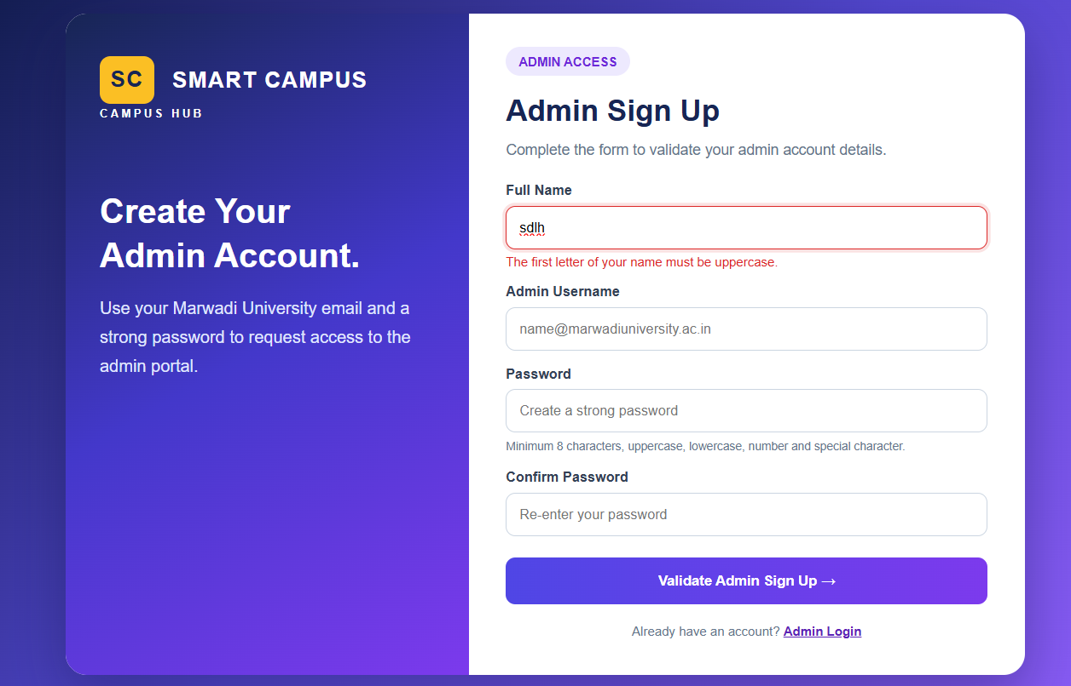

Fig 1.3 JS Validation:Name validation pattern

Admin username validation:-
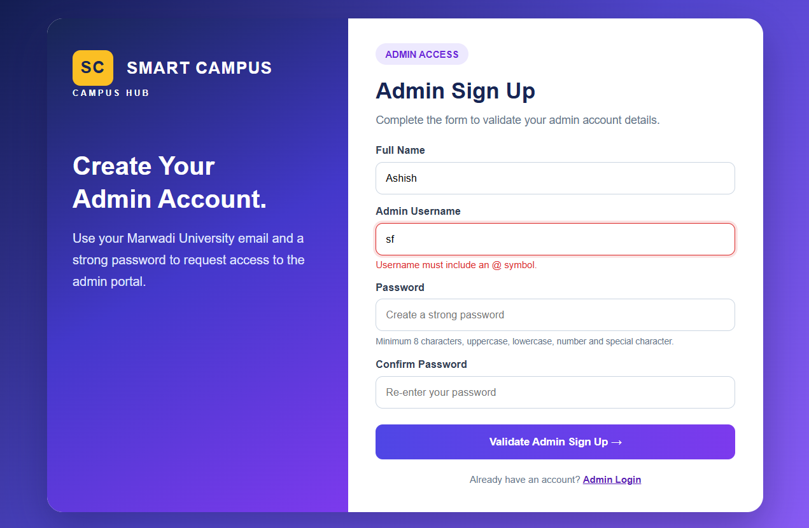
Fig 1.4 JS Validation: Admin username validation pattern

Password validation:-
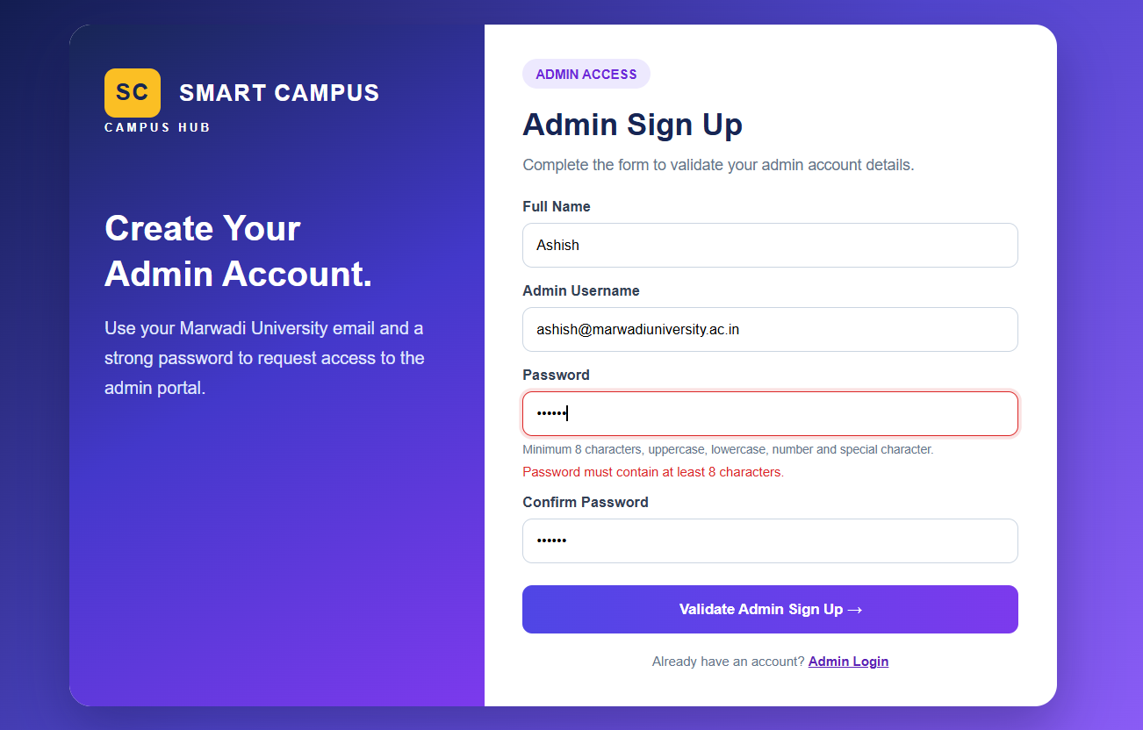
Fig 1.5 JS Validation:Password validation pattern

Conform password:-
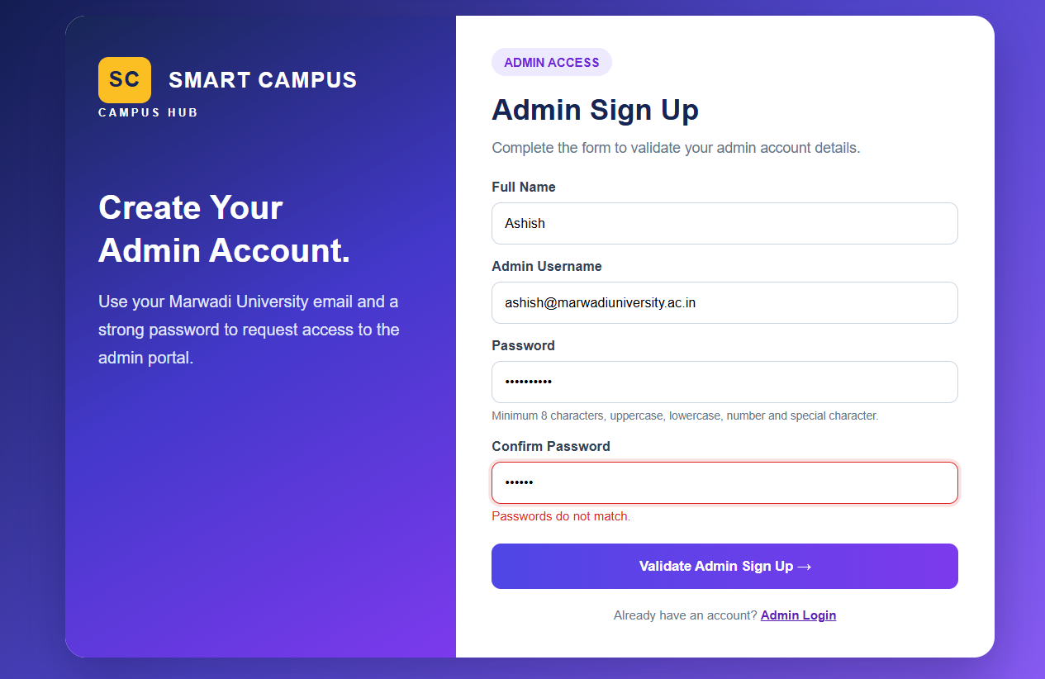
Fig 1.6 JS Validation:Conform password validation pattern

Login.html:-
<!DOCTYPE html>
<html lang="en">
<head>
<meta charset="UTF-8">
<meta name="viewport" content="width=device-width, initial-scale=1.0">
<title>Smart Campus Hub - Admin Login</title>
<style>
* {
box-sizing: border-box;
margin: 0;
padding: 0;
}
body {
font-family: Arial, sans-serif;
min-height: 100vh;
display: flex;
align-items: center;
justify-content: center;
padding: 20px;
background: linear-gradient(135deg, #101b4b, #5145cd, #8b5cf6);
}
.login-layout {
display: flex;
width: 850px;
max-width: 100%;
min-height: 480px;
background: white;
border-radius: 20px;
overflow: hidden;
box-shadow: 0 20px 50px #10103c55;
}
.login-intro {
width: 50%;
padding: 40px 32px;
color: white;
background: linear-gradient(150deg, #172554, #4338ca, #7c3aed);
}
.brand {
font-size: 21px;
font-weight: bold;
letter-spacing: 1px;
}
.brand-mark {
display: inline-block;
padding: 10px;
margin-right: 10px;
border-radius: 10px;
background: #fbbf24;
color: #172554;
}
.brand small {
display: block;
font-size: 10px;
letter-spacing: 3px;
margin-top: 4px;
}
.login-intro h1 {
font-size: 32px;
line-height: 1.3;
margin-top: 65px;
}
.login-intro p {
color: #e0e7ff;
line-height: 1.7;
margin-top: 15px;
}
.login-art {
margin-top: 35px;
height: 75px;
border-radius: 12px;
background: linear-gradient(90deg, #818cf8, #c4b5fd, #fbbf24);
}
.login-form {
width: 50%;
display: flex;
align-items: center;
padding: 35px;
}
.form-panel {
width: 100%;
}
h2 {
color: #172554;
font-size: 28px;
margin-top: 22px;
}
.muted {
color: #64748b;
font-size: 14px;
margin: 10px 0 25px;
}
.field {
margin-bottom: 17px;
}
label {
display: block;
color: #334155;
font-weight: bold;
font-size: 13px;
margin-bottom: 8px;
}
.input {
width: 100%;
padding: 13px;
border: 1px solid #cbd5e1;
border-radius: 9px;
outline: none;
font-size: 13px;
}
.input:focus {
border-color: #6366f1;
box-shadow: 0 0 0 3px #6366f122;
}
.error {
color: #dc2626;
font-size: 12px;
margin-top: 6px;
}
.button {
display: block;
width: 100%;
margin-top: 24px;
padding: 14px;
border: 0;
border-radius: 9px;
text-align: center;
text-decoration: none;
font-weight: bold;
color: white;
background: linear-gradient(90deg, #4f46e5, #7c3aed);
cursor: pointer;
}
.button:hover {
opacity: 0.9;
}
.note {
font-size: 11px;
color: #94a3b8;
text-align: center;
margin-top: 18px;
}
@media(max-width: 650px) {
.login-layout {
flex-direction: column;
}
.login-intro,
.login-form {
width: 100%;
}
.login-intro {
padding: 28px;
}
.login-intro h1 {
margin-top: 30px;
font-size: 27px;
}
.login-art {
height: 35px;
margin-top: 20px;
}
.login-form {
padding: 28px;
}
}
</style>
</head>
<body>
<div class="login-layout">
<section class="login-intro">
<div class="brand">
<span class="brand-mark">SC</span>
SMART CAMPUS
<small>CAMPUS HUB</small>
</div>
<h1>Keep Campus<br>Moving Forward.</h1>
<p>
Manage students, learning resources, campus events
and everything that makes student life better.
</p>
<div class="login-art"></div>
</section>
<section class="login-form">
<div class="form-panel">
<h2>Admin Portal</h2>
<p class="muted">
Welcome back! Sign in to manage Smart Campus Hub.
</p>
<form id="loginForm" action="admin-dashboard.html">
<div class="field">
<label for="username">Admin Username</label>
<input
class="input"
id="username"
name="username"
type="text"
value="ashish.kumar141661@marwadiuniversity.ac.in"
placeholder="Enter your email"
autocomplete="username"
>
<p id="usernameError" class="error"></p>
</div>
<div class="field">
<label for="password">Password</label>
<input
class="input"
id="password"
name="password"
type="password"
placeholder="Enter your password"
autocomplete="current-password"
minlength="8"
pattern="(?=.*[A-Za-z])(?=.*[0-9]).{8,}"
title="Password must be at least 8 characters and contain at least one letter and one number."
required
>
<p class="error" id="passwordError"></p>
</div>
<button class="button" type="submit">
Enter Admin Portal →
</button>
</form>
<p class="note">
Need an admin account?
<a href="admin-signup.html">Sign up</a>
</p>
<p class="note">
© 2026 Smart Campus Hub | Admin Access Only
</p>
</div>
</section>
</div>
<script>
const loginForm = document.getElementById("loginForm");
const username = document.getElementById("username");
const usernameError = document.getElementById("usernameError");
const password = document.getElementById("password");
const passwordError = document.getElementById("passwordError");
function validateUsername() {
const email = username.value.trim();
const emailPattern =
/^[A-Za-z0-9._%+-]+@marwadiuniversity\.ac\.in$/;
if (email === "") {
usernameError.textContent = "Username is required.";
return false;
}
if (!emailPattern.test(email)) {
usernameError.textContent =
"Enter a valid Marwadi University email address.";
return false;
}
usernameError.textContent = "";
return true;
}
username.addEventListener("input", validateUsername);
password.addEventListener("input", function() {
if (password.value === "" || password.validity.valid) {
passwordError.textContent = "";
} else {
passwordError.textContent =
"Password must be at least 8 characters and contain at least one letter and one number.";
}
});
loginForm.addEventListener("submit", function(event) {
if (!validateUsername() || !password.validity.valid) {
event.preventDefault();
}
});
</script>
</body>
</html>

Singup.html:-
<!DOCTYPE html>
<html lang="en">
<head>
<meta charset="UTF-8">
<meta name="viewport" content="width=device-width, initial-scale=1.0">
<title>Smart Campus Hub - Admin Sign Up</title>
<style>
* {
box-sizing: border-box;
margin: 0;
padding: 0
}
body {
font-family: Arial, sans-serif;
min-height: 100vh;
display: flex;
align-items: center;
justify-content: center;
padding: 20px;
background: linear-gradient(135deg, #101b4b, #5145cd, #8b5cf6);
}
.signup-layout {
display: flex;
width: 900px;
max-width: 100%;
min-height: 540px;
background: white;
border-radius: 20px;
overflow: hidden;
box-shadow: 0 20px 50px #10103c55;
}
.signup-intro {
width: 42%;
padding: 40px 32px;
color: white;
background: linear-gradient(150deg, #172554, #4338ca, #7c3aed);
}
.brand {
font-size: 21px;
font-weight: bold;
letter-spacing: 1px;
}
.brand-mark {
display: inline-block;
padding: 10px;
margin-right: 10px;
border-radius: 10px;
background: #fbbf24;
color: #172554;
}
.brand small {
display: block;
font-size: 10px;
letter-spacing: 3px;
margin-top: 4px;
}
.signup-intro h1 {
font-size: 32px;
line-height: 1.3;
margin-top: 65px;
}
.signup-intro p {
color: #e0e7ff;
line-height: 1.7;
margin-top: 15px;
}
.signup-form {
width: 58%;
display: flex;
align-items: center;
padding: 35px;
}
.form-panel {
width: 100%
}
.wire-label {
color: #6d28d9;
background: #ede9fe;
padding: 7px 12px;
border-radius: 20px;
font-size: 12px;
font-weight: bold;
}
h2 {
color: #172554;
font-size: 28px;
margin-top: 22px;
}
.muted {
color: #64748b;
font-size: 14px;
margin: 10px 0 20px;
line-height: 1.5;
}
.field {
margin-bottom: 14px
}
label {
display: block;
color: #334155;
font-weight: bold;
font-size: 13px;
margin-bottom: 7px;
}
.input {
width: 100%;
padding: 12px;
border: 1px solid #cbd5e1;
border-radius: 9px;
outline: none;
font-size: 13px;
}
.input:focus {
border-color: #6366f1;
box-shadow: 0 0 0 3px #6366f122;
}
.input.invalid,
.input.invalid:focus {
border-color: #dc2626;
box-shadow: 0 0 0 3px #dc262622;
}
.hint {
font-size: 11px;
color: #64748b;
margin-top: 5px;
line-height: 1.4;
}
.error {
color: #dc2626;
font-size: 12px;
margin-top: 5px;
}
.button {
display: block;
width: 100%;
margin-top: 20px;
padding: 14px;
border: 0;
border-radius: 9px;
text-align: center;
font-weight: bold;
color: white;
background: linear-gradient(90deg, #4f46e5, #7c3aed);
cursor: pointer;
}
.button:hover {
opacity: .9
}
.message {
display: none;
margin-top: 15px;
padding: 12px;
border-radius: 9px;
background: #dcfce7;
color: #166534;
font-size: 13px;
line-height: 1.5;
}
.note {
font-size: 12px;
color: #64748b;
text-align: center;
margin-top: 18px;
}
.note a {
color: #5b21b6;
font-weight: bold;
}
@media(max-width:650px) {
.signup-layout {
flex-direction: column
}
.signup-intro,
.signup-form {
width: 100%
}
.signup-intro {
padding: 28px
}
.signup-intro h1 {
margin-top: 30px;
font-size: 27px
}
.signup-form {
padding: 28px
}
}
</style>
</head>
<body>
<div class="signup-layout">
<section class="signup-intro">
<div class="brand">
<span class="brand-mark">SC</span>
SMART CAMPUS
<small>CAMPUS HUB</small>
</div>
<h1>Create Your<br>Admin Account.</h1>
<p>
Use your Marwadi University email and a strong
password to request access to the admin portal.
</p>
</section>
<section class="signup-form">
<div class="form-panel">
<span class="wire-label">ADMIN ACCESS</span>
<h2>Admin Sign Up</h2>
<p class="muted">
Complete the form to validate your admin account details.
</p>
<form id="signupForm" novalidate>
<!-- Full Name -->
<div class="field">
<label for="fullName">Full Name</label>
<input class="input" id="fullName" name="fullName" type="text"
placeholder="Enter your full name" autocomplete="name">
<p class="error" id="nameError" aria-live="polite"></p>
</div>
<!-- Username -->
<div class="field">
<label for="username">Admin Username</label>
<input class="input" id="username" name="username" type="text"
placeholder="name@marwadiuniversity.ac.in" autocomplete="username">
<p class="error" id="usernameError" aria-live="polite"></p>
</div>
<!-- Password -->
<div class="field">
<label for="password">Password</label>
<input class="input" id="password" name="password" type="password"
placeholder="Create a strong password" autocomplete="new-password">
<p class="hint">
Minimum 8 characters, uppercase, lowercase,
number and special character.
</p>
<p class="error" id="passwordError" aria-live="polite"></p>
</div>
<!-- Confirm Password -->
<div class="field">
<label for="confirmPassword">Confirm Password</label>
<input class="input" id="confirmPassword" name="confirmPassword" type="password"
placeholder="Re-enter your password" autocomplete="new-password">
<p class="error" id="confirmError" aria-live="polite"></p>
</div>
<button class="button" type="submit">
Validate Admin Sign Up →
</button>
<p class="message" id="message" role="status"></p>
</form>
<p class="note">
Already have an account?
<a href="admin-login.html">Admin Login</a>
</p>
</div>
</section>
</div>
<script>
const form = document.getElementById("signupForm");
const fullName = document.getElementById("fullName");
const username = document.getElementById("username");
const password = document.getElementById("password");
const confirmPassword = document.getElementById("confirmPassword");
const nameError = document.getElementById("nameError");
const usernameError = document.getElementById("usernameError");
const passwordError = document.getElementById("passwordError");
const confirmError = document.getElementById("confirmError");
const message = document.getElementById("message");
function showFieldError(field, errorElement, text) {
errorElement.textContent = text;
field.classList.add("invalid");
field.setAttribute("aria-invalid", "true");
}
function clearFieldError(field, errorElement) {
errorElement.textContent = "";
field.classList.remove("invalid");
field.setAttribute("aria-invalid", "false");
}
// 1. Full Name Validation
function validateName() {
const name = fullName.value.trim();
if (name.length < 2) {
showFieldError(fullName, nameError,
"Full name must contain at least 2 characters.");
return false;
}
if (name.length > 80) {
showFieldError(fullName, nameError,
"Full name cannot exceed 80 characters.");
return false;
}
const firstLetter = Array.from(name)[0];
if (firstLetter !== firstLetter.toLocaleUpperCase()) {
showFieldError(fullName, nameError,
"The first letter of your name must be uppercase.");
return false;
}
if (!/^[\p{L}\p{M}]+(?:[ '\u2019-][\p{L}\p{M}]+)*$/u.test(name)) {
showFieldError(fullName, nameError,
"Enter a valid name using letters and spaces.");
return false;
}
clearFieldError(fullName, nameError);
return true;
}
// 2. Username / Email Validation
function validateUsername() {
const email = username.value.trim();
const emailPattern =
/^[A-Za-z0-9._%+-]+@marwadiuniversity\.ac\.in$/i;
if (email === "") {
showFieldError(username, usernameError, "Username is required.");
return false;
}
if (!email.includes("@")) {
showFieldError(username, usernameError,
"Username must include an @ symbol.");
return false;
}
if (!emailPattern.test(email)) {
showFieldError(username, usernameError,
"Use a valid @marwadiuniversity.ac.in email address.");
return false;
}
clearFieldError(username, usernameError);
return true;
}
// 3. Password Validation
function validatePassword() {
const pass = password.value;
if (pass.length < 8) {
showFieldError(password, passwordError,
"Password must contain at least 8 characters.");
return false;
}
if (!/[A-Z]/.test(pass)) {
showFieldError(password, passwordError,
"Include at least one uppercase letter.");
return false;
}
if (!/[a-z]/.test(pass)) {
showFieldError(password, passwordError,
"Include at least one lowercase letter.");
return false;
}
if (!/[0-9]/.test(pass)) {
showFieldError(password, passwordError,
"Include at least one number.");
return false;
}
if (!/[^A-Za-z0-9]/.test(pass)) {
showFieldError(password, passwordError,
"Include at least one special character.");
return false;
}
clearFieldError(password, passwordError);
return true;
}
// 4. Confirm Password Validation
function validateConfirmPassword() {
if (confirmPassword.value === "") {
showFieldError(confirmPassword, confirmError,
"Please confirm your password.");
return false;
}
if (confirmPassword.value !== password.value) {
showFieldError(confirmPassword, confirmError,
"Passwords do not match.");
return false;
}
clearFieldError(confirmPassword, confirmError);
return true;
}
// Validate fields while typing
fullName.addEventListener("input", validateName);
username.addEventListener("input", validateUsername);
password.addEventListener("input", function () {
validatePassword();
if (confirmPassword.value !== "") {
validateConfirmPassword();
}
});
confirmPassword.addEventListener("input", validateConfirmPassword);
// 5. Form Submit Validation
form.addEventListener("submit", function (event) {
event.preventDefault();
message.style.display = "none";
const nameValid = validateName();
const usernameValid = validateUsername();
const passwordValid = validatePassword();
const confirmValid = validateConfirmPassword();
if (
!nameValid ||
!usernameValid ||
!passwordValid ||
!confirmValid
) {
return;
}
message.textContent =
"All validations passed! Your details are valid. " +
"Account registration is not connected to a server yet.";
message.style.display = "block";
});
</script>
</body>
</html>

